**Facial recognition attendance system**

List of members:

1. Dhale Joshua G. Aliviado
2. Lovely jean C. Acibes
3. Angeline Q. Altubar
4. Rican J. Elepan

**Screenshot of Added Client-Side Feature**

Student recognition

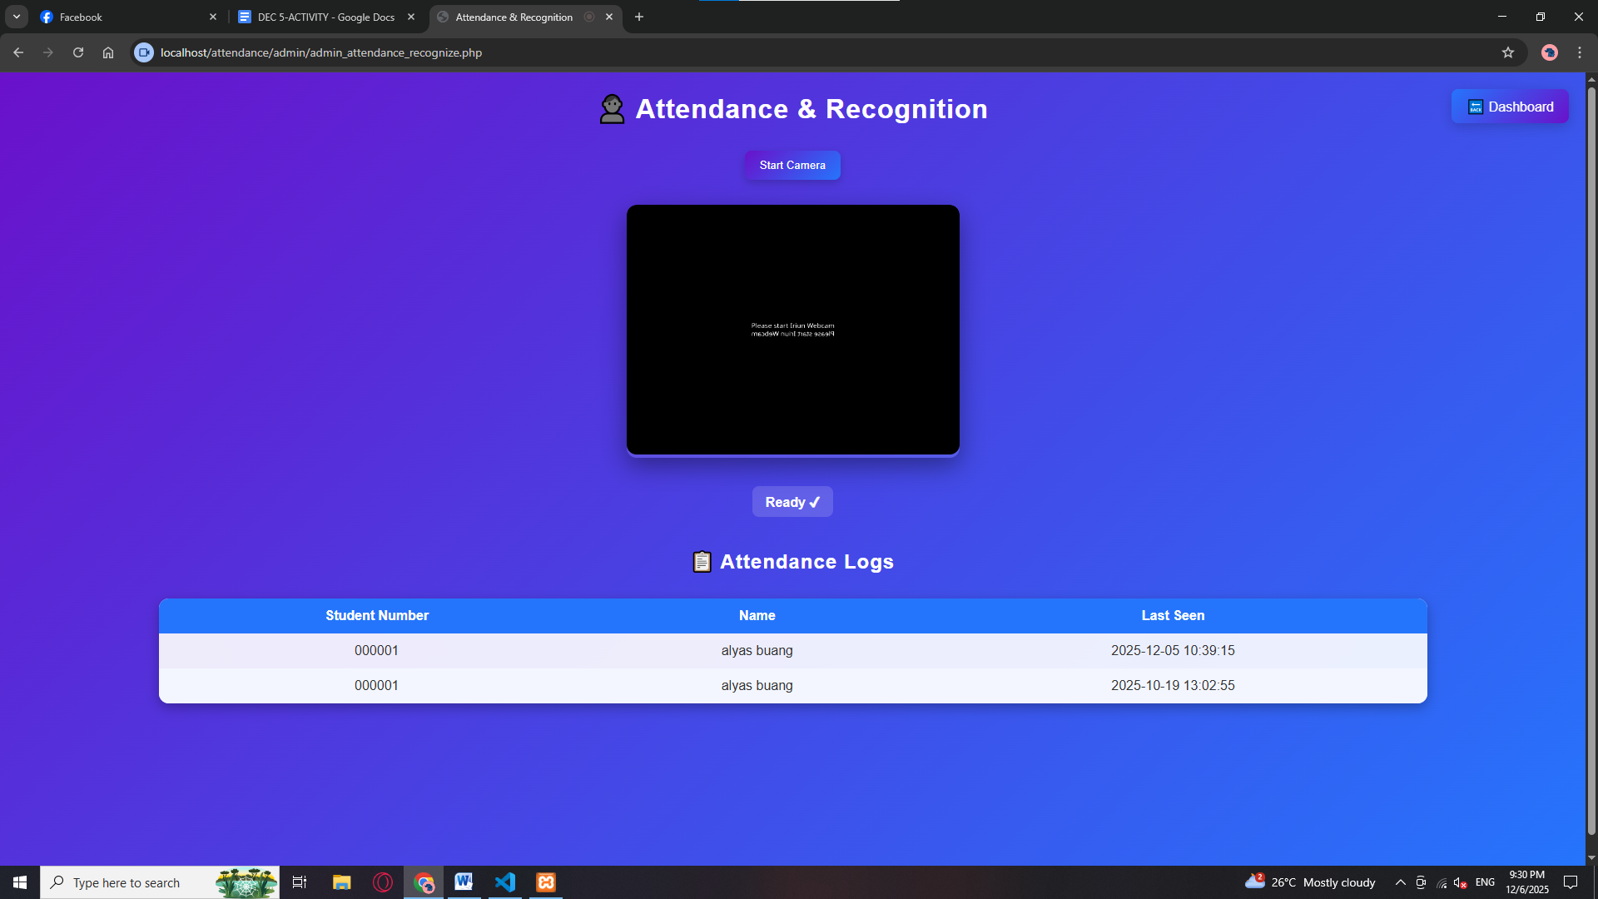

Student registration

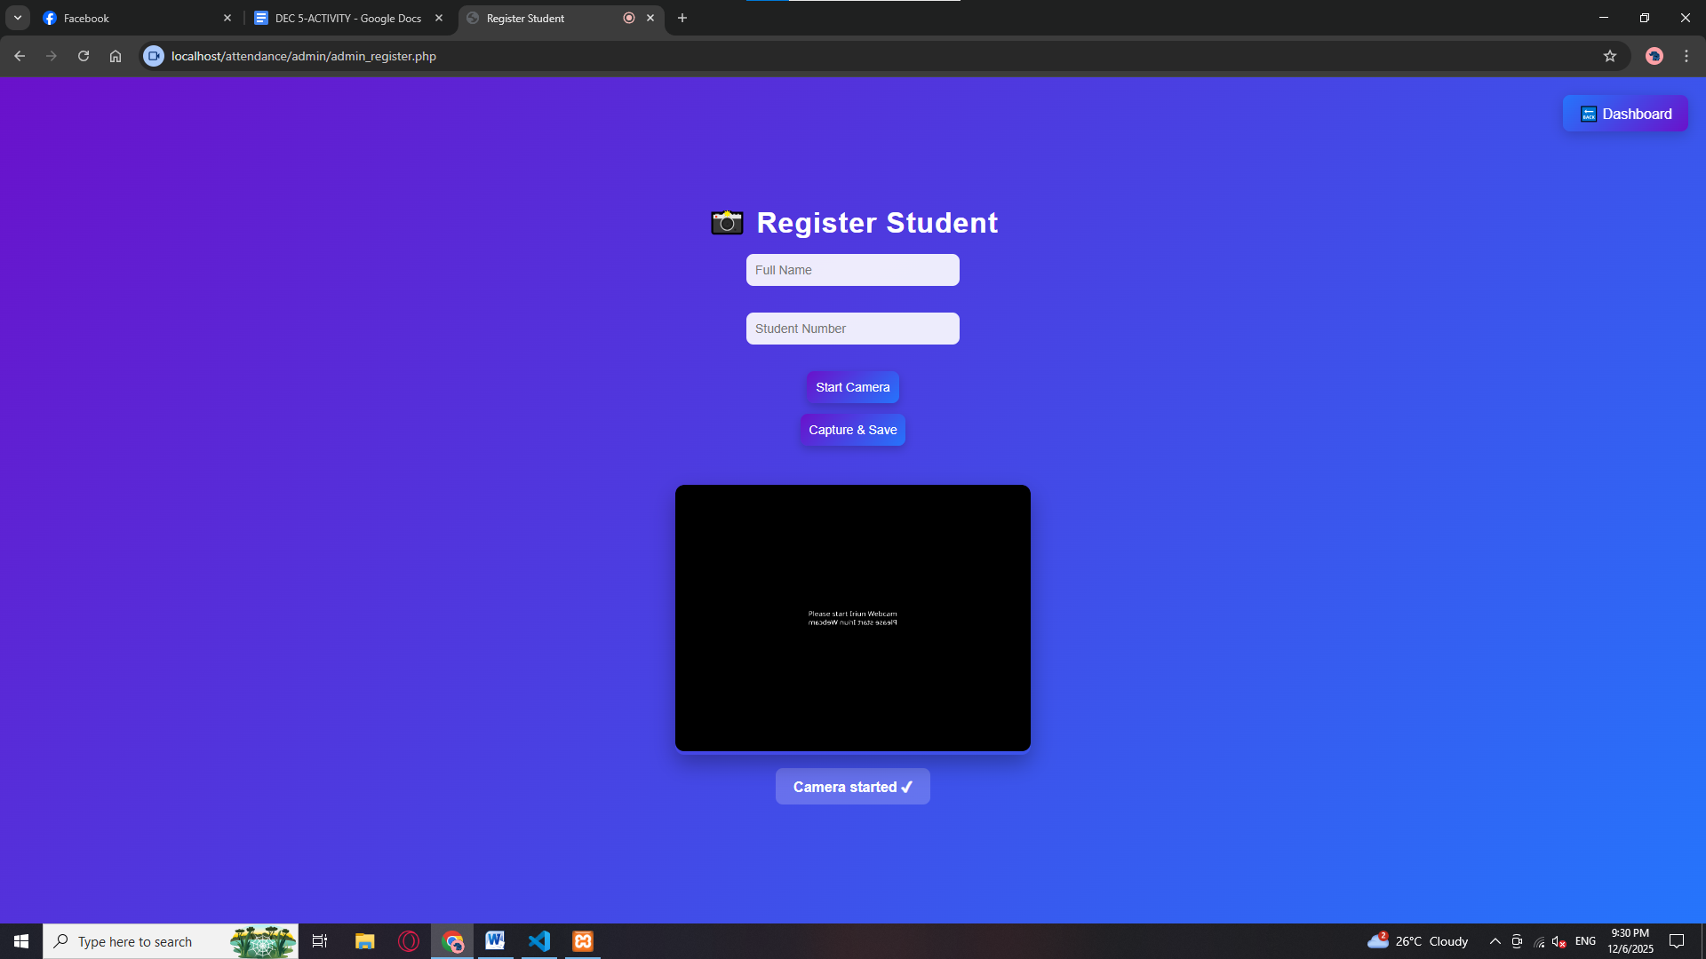

Attendance logs

